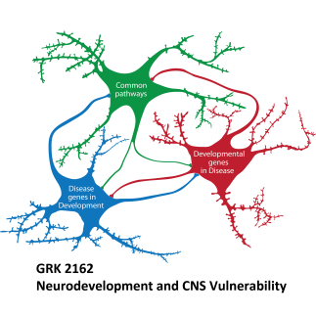
First International Symposium

“Neurodeveloment and Vulnerability of the Central Nervous System”

September 19th – 21st, 2018 (Erlangen, Germany)

Limited places available - Application Deadline: June 30, 2018

Submit to: GRK2162-symposium@fau.de

First Name:

Surname:

Affiliation:

Address:

Email:

Abstract (max. 250 words excluding title, authors and affiliations):

